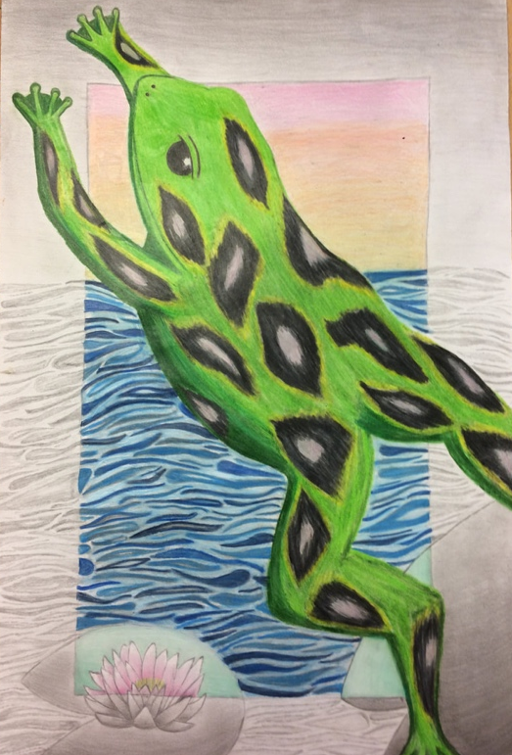
BEYOND THE BORDER

1. Choose 3 animals you may want to draw.
2. Divide 1 piece of sketchbook paper into thirds.
3. On your sheet of paper, create 1 different composition (layout
or idea) per section using the animals of your choice.
4. When you have 3 DIFFERENT ideas, get your sketches checked off
and choose favorite.
5. ONCE DESIGN IS APPROVED, begin sketching your design on the
“Final Draft” paper.
6. Once you have it drawn in roughly (It does not have to be finished
completely) add your border. Do this by measuring 3 inches in on each side of your paper.
Continue sketching in your subject matter.
Remember: The subject matter (animal) should be overlapping the border.
7. GET CHECKED OFF once everything is drawn in. Erase any of the border line that crosses
over your animal.
8. ONCE APPROVED- Begin coloring in animal
9. ONCE ANIMAL IS COLORED IN- begin coloring in everything INSIDE the border
10. ONCE EVERYTHING INSIDE BORDER + ANIMAL IS COLORED IN- begin shading everything else.

Continue until project is complete!

HINT- Start with top of paper when shading in with graphite. Work your way down the paper to prevent smudging.

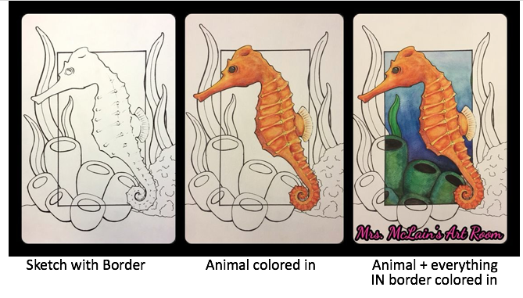

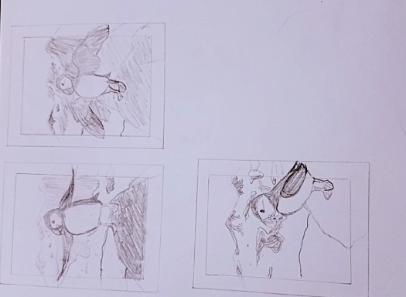
Beyond the Border Grading Criteria | Worth:
Observational Skills- Ability to create proper value changes. Colors used closely resembled correct colors from source images | 20 / 100
Shading/Blending- Use of 2H, HB and 4B pencils for shading. Blending tools used for value changes. Prismacolors used to color. Color blending completed skillfully. | 20 / 100
Proportion/Layout- Objects must fill page appropriately. VA COMP: Layout and subject matter feature more complex shapes. | 20 / 100
Time Management/Research- Student paced self. Did not rush through project and also did not waste time researching source images. Student stayed on task throughout duration of project. | 20 / 100
Craftsmanship- Work must me neat, clean, & complete. Student must demonstrate skillful use of the art tools & media. | 20 / 100

