Creating A Still Life

STILL LIFE. Steps 1 to 4: These steps demonstrate how to draw the shapes and proportions of the still life objects using line.

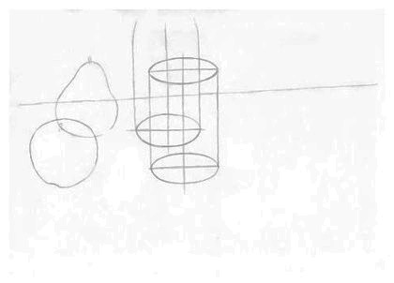

STEP 1: STARTING THE STILL LIFE DRAWING. LIGHTLY draw the objects as if they are transparent wire frame forms with visible lines of construction.

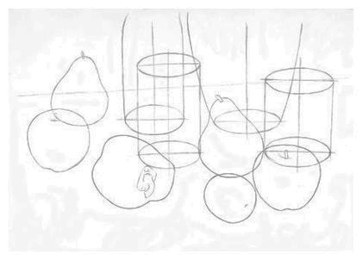
STEP 2: CREATING AN INTERESTING COMPOSITION. When composing a still life, try to introduce the qualities that make an interesting arrangement. You need to be aware of the abstract structure of your arrangement: its rhythms and contrasts of line, shape, tone, color, pattern, texture and form.

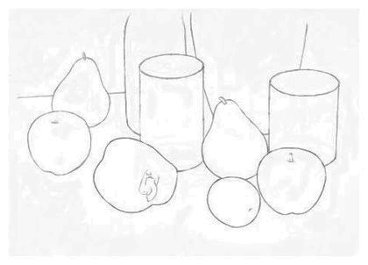

STEP 3: ERASING THE LINES OF CONSTRUCTION. Once you are happy with the shape, proportion and composition of the still life, you can erase the lines of transparent construction.

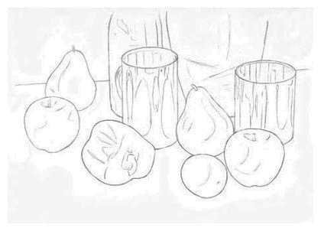

STEP 4: ADDING THE DETAILS IN LINE. Now lightly sketch in the shapes of any shadows or reflections onto each object. NOTE: The more care you take over the accuracy of these marks, the easier you will find the next stage of the drawing - the Application of Tone.

Steps 5 to 8: These steps illustrate how to render the three-dimensional form of the still life using tone.

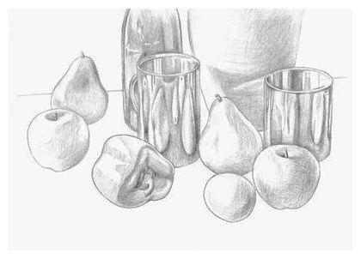

STEP 5: SHADING TECHNIQUE - 1. The tone of our still life is built up in four stages outlined in steps 5 - 8. In this step, some basic tones are lightly applied to each object to help build up its three-dimensional form.

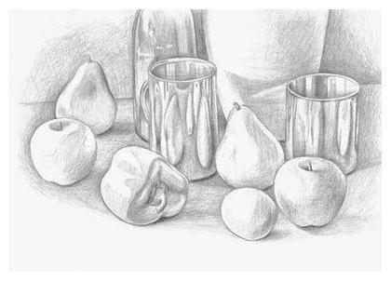
STEP 6: SHADING TECHNIQUE - 2. The second stage in building up the tone focuses on the spaces between and around the objects. NOTE: The drawing of the light and shade between the objects must be treated with as much importance as the drawing of the objects themselves.

STEP 7: SHADING TECHNIQUE - 3. In the third stage of building up the tone, you focus back on the objects. This time you deepen their tone, increasing the contrast between the areas of dark and light. This will enhance the form of the objects and increase the impact of the image.

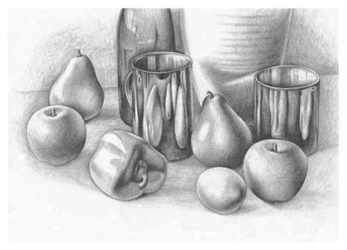

STEP 8: SHADING TECHNIQUE - 4. Finally, you focus again on the spaces between the objects, deepening their tones and increasing their contrast.

NOTE: You need to be careful in balancing the tonal values of the objects and the spaces between them to ensure that you create a unified image.

