VA COMP HOMEWORK

COMPLETION INCLUDES:
FULL COLOR OR FULL VALUE – 25 POINTS
FULL PAGE (8.5X11 MINIMUM) – 25 POINTS
FULL EFFORT (1HR. MINIMUM)– 25 POINTS
MET SPECIFIC REQUIREMENTS– 25 POINTS

Notebook Paper Drawing: Follow the step-by-step directions provided to create a drawing of crumpled notebook paper.

Before you Begin: Crumple a piece of paper and set it up somewhere where you can see interesting shadows. DO NOT JUST USE A PHOTO FROM THE INTERNET

Step 1: Create a light line sketch. You may want to start with an outline first.
Step 2: Once you are happy with the overall shape, begin shading edges and folds of paper.
Step 3: Add Blue lines that follow the folds and bends, red lines, cast shadow

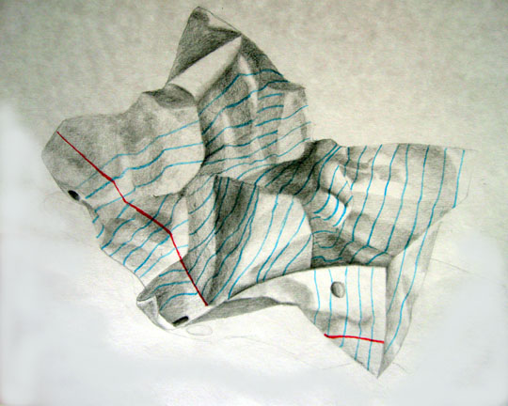
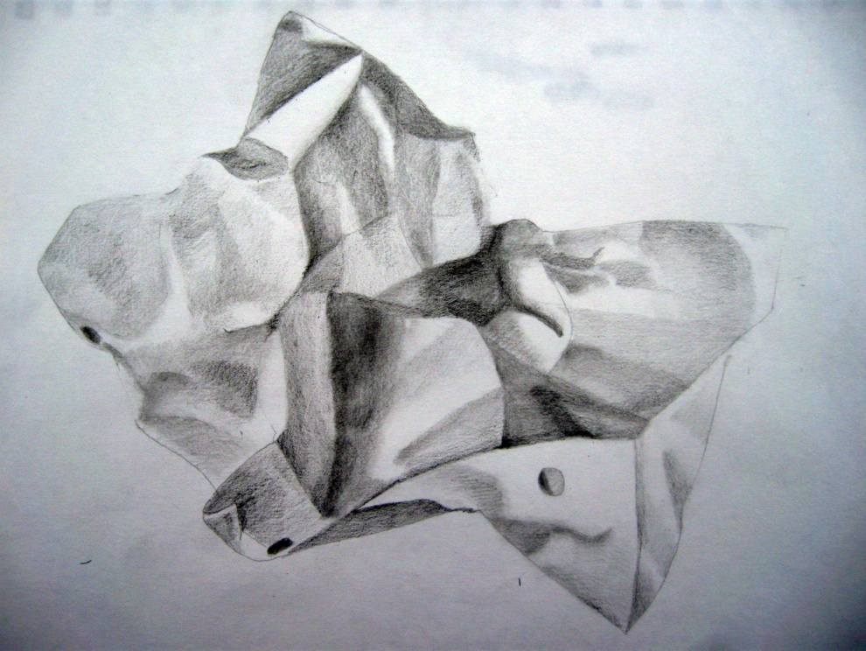

Check to make sure blue lines and red lines follow the FOLDS in the paper (Don’t just draw straight lines)

Remember: These assignments are designed to help you grow as an artist. Take chances! Use mediums you are less familiar with. Ask for help if needed. This is a completion grade, so accuracy is not the MOST important part. Just be sure to follow project descriptions and procedures. Have fun creating beautiful work!

