Student Name:

Lesson: Edward Gorey Dreams & Nightmares
Circle the number in pencil that best shows how well you feel that you completed that criterion for the assignment. |  | Excellent | Good | Average | Needs Improvement
Criteria 1 – Composition: Successful overall composition of dreamlike environment. Subject matter well placed within the environment. |  | 10 | 9 – 8 | 7 | 6 or less
Criteria 2 – Incorporation of Dreamlike imagery: Student utilized imagery from dreams or nightmares from their descriptions. These could be subtle or blatant. |  | 10 | 9 – 8 | 7 | 6 or less
Criteria 3 – Texture. Student utilized MANY different textures through the use of lines, hatching, cross-hatching, etc. EVERY surface should be filled with some sort of texture. |  | 10 | 9 – 8 | 7 | 6 or less
Criteria 4 – Value: Student used different values created from how close or far apart the lines are. Should have lights, darks, and midtones well developed within the artwork. |  | 10 | 9 – 8 | 7 | 6 or less
Criteria 5 – Effort: took time to develop idea & complete project? (Didn’t rush.) Read the article and followed the steps within. Good use of class time? |  | 10 | 9 – 8 | 7 | 6 or less
Criteria 6 – Craftsmanship – Neat, clean & complete? Skillful use of the art tools & media? |  | 10 | 9 – 8 | 7 | 6 or less
Total: 60  (possible points) /60 pts | Grade:
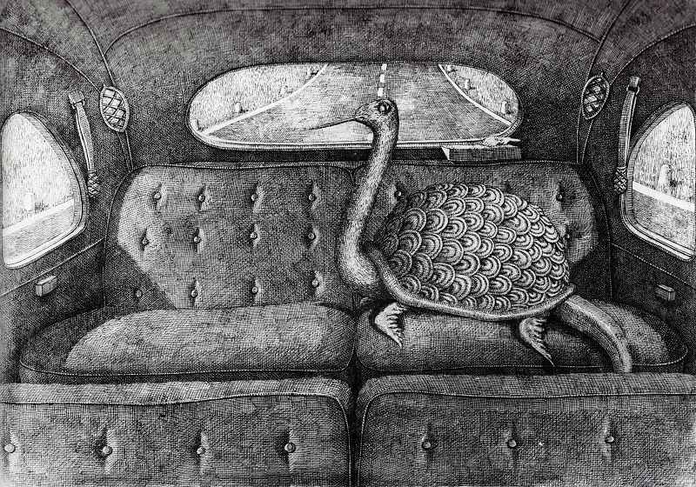

------------ Dreams & Nightmares -------------------------------------

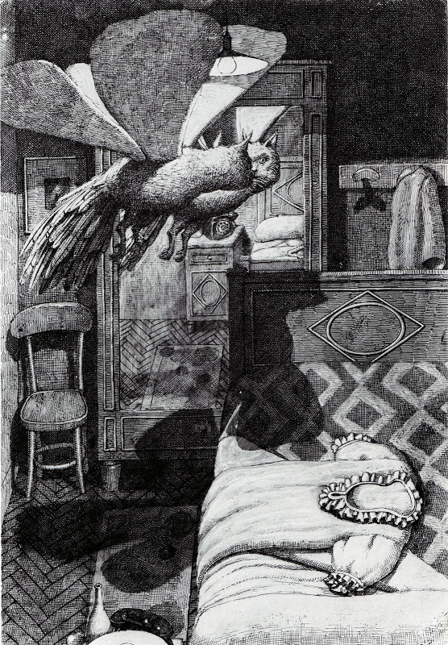
STEPS TO FOLLOW:
- Take some time to describe at least three previous dreams you have had on the handout given to you.
- Next, underline all the descriptive nouns within your paragraphs.
- Then you will get photographic images of your descriptive nouns from online and copy them to a one-page word document.
- You will print out this one page and use the images you printed to create 3 thumbnail sketches using your dreams as your subject matter.
- Then Mrs. Denison will help you to look over and pick the best sketch to create for your larger composition.
- Then you will draw your best idea onto the 9x12 paper in pencil.
- Finally, you will use a black, ballpoint pen to add textures to EVERY section of the paper.

