VA COMP HOMEWORK

COMPLETION INCLUDES:
FULL COLOR OR FULL VALUE – 25 POINTS
FULL PAGE (8.5X11 MINIMUM) – 25 POINTS
FULL EFFORT (1HR. MINIMUM)– 25 POINTS
MET SPECIFIC REQUIREMENTS– 25 POINTS

Eye: Create a detailed drawing of your eye and the area around it. Include everything you see when observing closely in clear, even light. If you would see nose or eyebrow, be sure to include those. FILL PAGE

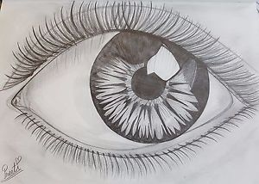
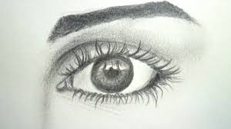

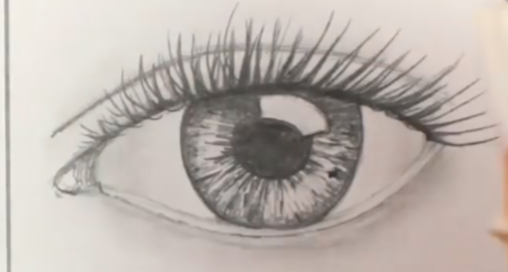

Remember: These assignments are designed to help you grow as an artist. Take chances! Use mediums you are less familiar with. Ask for help if needed. This is a completion grade, so accuracy is not the MOST important part. Just be sure to follow project descriptions and procedures. Have fun creating beautiful work!

