Illuminated Manuscripts
Designing Letter

- Choose a letter to work with (This could the letter of your first or last name, or another letter of your choice).
- Look at some of the lettering styles (fonts) given and use them to draw out your letter in 4 different styles. (1/4 of a page each = 1 page of possible letters).
- Next, look for some images that you can add as designs to your surround you letter. These can be images based on previous Illuminations or you can look for images in books or online. You MUST incorporate 5-8 decorations that represent you in some way. Sketch these out on a another piece of paper in your sketchbook.

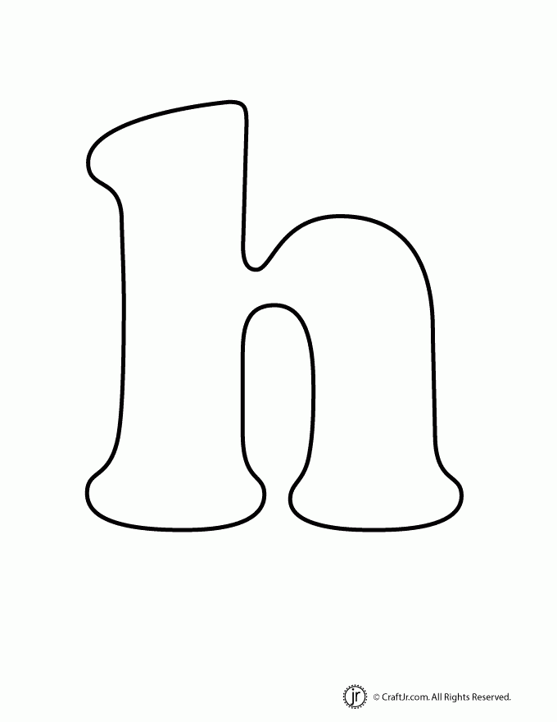

Rough and Final Drafts

- Pick the best letter from your 4 sketches as well as the 4-5 items you wish to include with it.
- Take a ruler and line it up with the outer edges of your paper. Mark the inside edge of the ruler on all 4 sides. This should give you a thick border.
- Next, from the border, measure in 1 inch on each side. This will give you a slim “frame”.
- Now add your letter. Letter MUST overlap “frame” on AT LEAST 2 sides. (Draw letter LARGE)
- Next, fill in frame with designs. Then begin filling the inside of frame with additional, larger designs. LEAVE OUTER BORDER BLANK.
- Once your rough draft is completed, you will transfer your design to your final paper by using the light table to trace your design.
- The more complex patterns you add, the better!!!
- You will then add bright color to your design using colored pencils. The outlines will be done last with colored pencil to make the color stand out.

7th Grade: Illuminated Letter Color Theory |  |  | Student Name:  Class Period:
Circle the number that best shows how well you feel that you completed that criterion for the assignment. |  | Excellent | Good | Average |  | Needs Improvement
Design/ Composition: The letter is large and the main focal point. There is a boarder with decoration around the letter. There is not too much negative space shown within the paper. |  | 10 | 9 – 8 | 7 |  | 6 or less
Color Application: Colored pencils are used so that the color is bright and stands out like paint on the page. Pencils have been blended together to create new colors. |  | 10 | 9 – 8 | 7 |  | 6 or less
Pattern:– 5-8 complex patterns have been used within the image. Pattern has been used in the letter, in the boarders, and in the spaces in between. |  | 10 | 9 – 8 | 7 |  | 6 or less
Effort: took time to develop idea & complete project? (Didn’t rush.) Good use of class time? |  | 10 | 9 – 8 | 7 |  | 6 or less
Craftsmanship – Neat, clean & complete? Skillful use of the art tools & media? |  | 10 | 9 – 8 | 7 |  | 6 or less
Total: 50  (possible points) | Grade: /50 = |  | Your Total |  | Teacher Total

7th Grade: Illuminated Letter Color Theory |  |  | Student Name:  Class Period:
Circle the number that best shows how well you feel that you completed that criterion for the assignment. |  | Excellent | Good | Average |  | Needs Improvement
Design/ Composition: The letter is large and the main focal point. There is a boarder with decoration around the letter. There is not too much negative space shown within the paper. |  | 10 | 9 – 8 | 7 |  | 6 or less
Color Application: Colored pencils are used so that the color is bright and stands out like paint on the page. Pencils have been blended together to create new colors. |  | 10 | 9 – 8 | 7 |  | 6 or less
Pattern:– 5-8 complex patterns have been used within the image. Pattern has been used in the letter, in the boarders, and in the spaces in between. |  | 10 | 9 – 8 | 7 |  | 6 or less
Effort: took time to develop idea & complete project? (Didn’t rush.) Good use of class time? |  | 10 | 9 – 8 | 7 |  | 6 or less
Craftsmanship – Neat, clean & complete? Skillful use of the art tools & media? |  | 10 | 9 – 8 | 7 |  | 6 or less
Total: 50  (possible points) | Grade: /50 = |  | Your Total |  | Teacher Total

