VA COMP HOMEWORK

COMPLETION INCLUDES:
FULL COLOR OR FULL VALUE – 25 POINTS
FULL PAGE (8.5X11 MINIMUM) – 25 POINTS
FULL EFFORT (1HR. MINIMUM)– 25 POINTS
MET SPECIFIC REQUIREMENTS– 25 POINTS

Lyrics: Draw your favorite poem or song lyrics. (Include the poem or song lyrics as part of your drawing, or on the next page.) LYRICS MUST BE INCLUDED (Printed and attached) FOR FULL CREDIT.

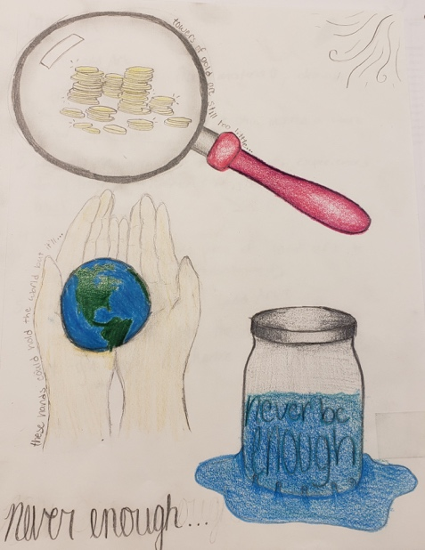
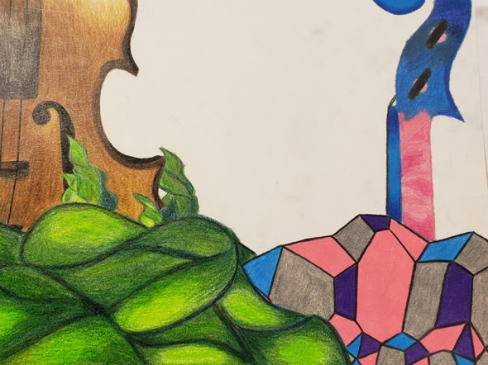
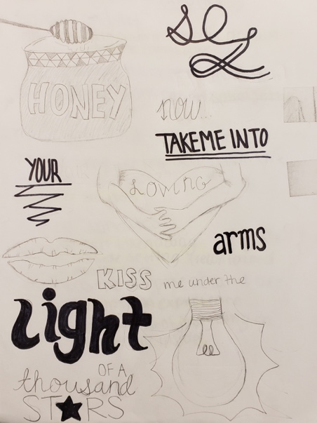

Remember: These assignments are designed to help you grow as an artist. Take chances! Use mediums you are less familiar with. Ask for help if needed. This is a completion grade, so accuracy is not the MOST important part. Just be sure to follow project descriptions and procedures. Have fun creating beautiful work!

