PRINTMAKING MADE EASY!

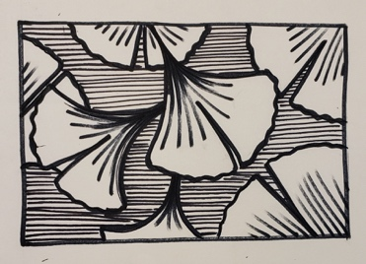
Step 1. Design and Draw
Get inspired! Begin by researching source images from magazines.
Begin sketches- Create 3 DIFFERENT, but also SIMPLE 4” x 6” designs (Insects/Plants/Animals)
Pick your top design and clean it up.
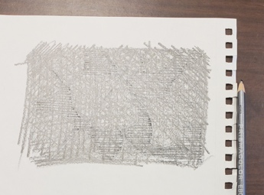
Remember: The exact image will be transferred to your linoleum block so measuring is a MUST. You will essentially be creating a large stamp so your drawing should go on the block the opposite way that you want it to be printed.
Step 2. Transferring On to the Linoleum Block

Start by shading the back of your design with an EBONY pencil. The ENTIRE back of you design must be covered for this to work.
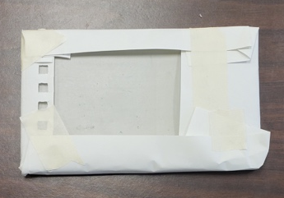

Next, you will need to wrap you design (Drawing side UP) around your linoleum block and use tape to hold the design in place.

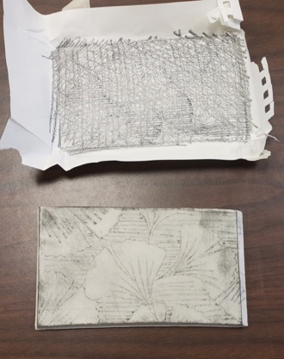
Next, trace over the lines you have drawn in colored pencil to transfer the design onto the block, by pressing the pencil down firmly over the lines. The pressure transfers the image whereas the colored pencil helps you to see which lines you have gone over.

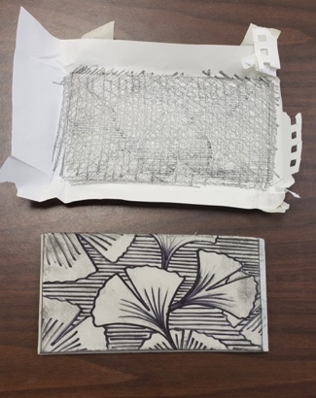
After you have transferred the design onto the linoleum, fill in any small areas that you missed with pencil, or add in any details that you feel necessary. You can trace these lines with a sharpie if your lines are smudging away.

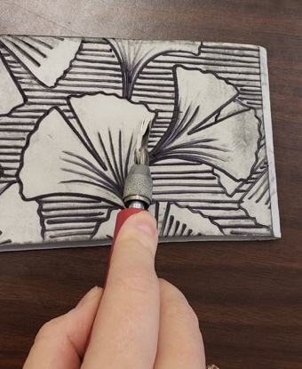
Step 3: Carving the Linoleum Block
Reminder: Never cut towards your hand or towards you body! Always cut away from yourself! Keep your hands out of the path of the blade!
Start by using a V shaped tool to carve out fine lines and to outline of the design. To remove more of the linoleum for bigger lines or larger areas of block, use a U shaped tool.

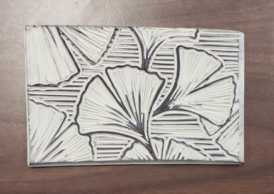
Remember to cut out the WHITE SPACE. This is the NEGATIVE SPACE. Your black lines are your POSTITIVE SPACE. This is what will print.
Remember: Once you make a cut, it is not easy to fix, and sometimes it is impossible to fix, so choose the right tool, make sure the tools are sharp, and go slow!

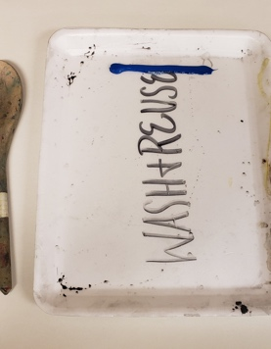
Step 4: Printing
Begin by squeezing ink onto your tray. DO NOT USE TOO MUCH INK. You can always add more, but taking ink away is time consuming, messy and can be frustrating.

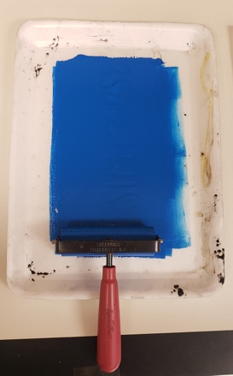
Roll your brayer (roller) in the ink until it is evenly coated. Do not get too much or too little ink on the roller. When you have the right amount of ink on the roller, it should make a sound like ripping Velcro when you roll the brayer back and forth.
Now taker your roller and roll it back and forth across your linoleum block, making sure you cover the entire thing evenly.

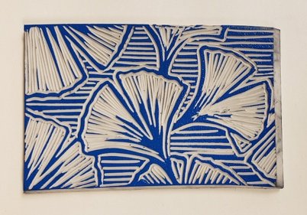

Make sure your hands are clean!

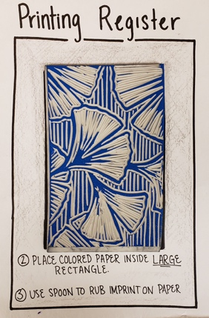

Next, place your printing block on your REGISTER.

Remember: You only have ONE chance to line up (or register) your print properly, so take your time. Next, add your piece of colored paper (Write your name on the back!) on top of the block, following the register.
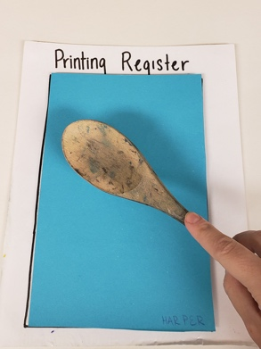
Now take your wooden spoon and rub, using the backside, curved side, to transfer the image. Go in even circles with the spoon and be sure to rub the entire area.
Lift the paper slowly and carefully, and lay it on the drying rack to dry.

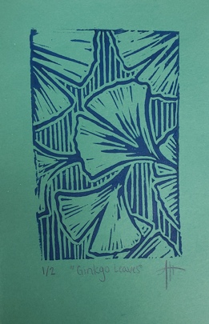
After every print you “pull”, you need to clean your block by making a GHOST PRINT. This is done by using a piece of Newsprint Paper (thin paper used to aid in the production of a project or as a protective layer). Make sure you throw away your ghost prints.
Next, you will need to re-ink the block. Repeat until you have 5 good prints.

Step 5: Signing Your Prints

Once your prints are dry, show the art teacher all 5 prints to get checked off. Put your top 3 on top. Once approved, you will need to sign your prints.

Under your print, you must write IN PENCIL, the edition # (1/3, 2/3 or 3/3), followed by the title in parenthesis, then followed by your Initials/ Signature.

You’re done! Now, fill out your rubric, paperclip your prints to it, MAKE SURE YOUR NAME IS ON EVERYTHING, and turn in your work!

