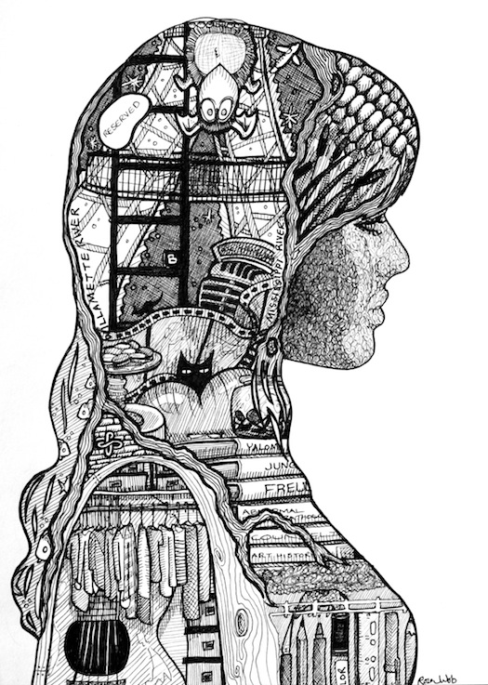

Self Portrait Project
Our next project will be an introductory lesson on portrait drawing.
Step 1: You will begin by identifying some of your interests and goals and compose a list of 15 them. Think about what your hobbies, talents and interests are. Also think about how you may be able to depict these interests, visually. You will be incorporating some of these elements within your self-portrait. Remember- This is supposed to depict what makes you the person you are or who you want to become.
Step 2: Have a partner trace the outline of your profile on a 12 x 18 piece of paper. Begin your artwork by drawing in your facial features. Don’t forget to add directional lines to define your hair. After features have been drawn proportionally and placed accurately, you will go back to your list and circle your top 7-8 interests.
Step 3: Once you have narrowed down some ideas, begin to fill in the empty areas of your portrait with the things that are important to you. It would be wise to practice how you want to represent each interest you have picked.
Step 4: After you have your interests sketched into place, begin using an art pen to outline them. Once the outline in finished, start using techniques like crosshatching and stippling to give your shapes more detail and dimension. Also, think about the elements of art and principles of design. Ask yourself things like, “Is my artwork balanced?”, “Does my work show unity?”
Elements: Shape, line, texture, space, value
Guiding Question: "Who am I?" "What makes me who I am?"

