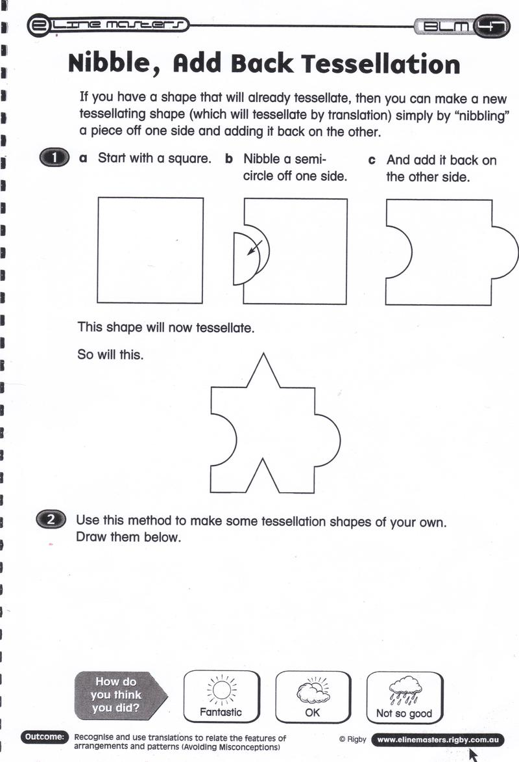

Create 4 different tessellations in your sketchbook. You can do this by cutting post-it notes and gluing them down, or draw by starting with squares. Once you have 4 different designs, practice using different color combinations to see what will “pop” off your page. Think of complimentary colors, or other color schemes.