VA COMP HOMEWORK LIST

COMPLETION INCLUDES:
FULL COLOR OR FULL VALUE – 25 POINTS
FULL PAGE (8.5X11 MINIMUM) – 25 POINTS
FULL EFFORT (1HR. MINIMUM)– 25 POINTS
MET SPECIFIC REQUIREMENTS– 25 POINTS

Where’s Waldo?: Take one sketchbook page and fill it in with miniature drawings of everything that relates to you and your life: gum, braces, football jersey, basketballs or soccer balls, etc. You have endless possibilities. The page must be filled, no blank space and all items are reduced to the same/similar size.

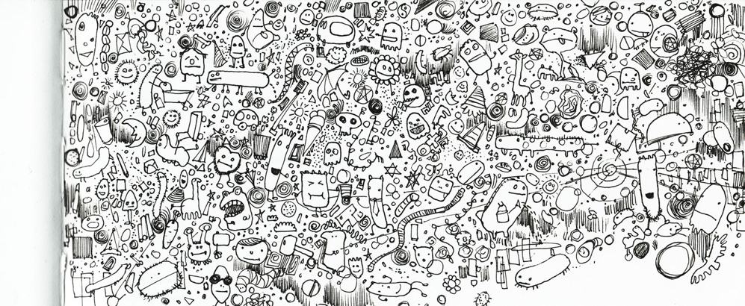

Remember: These assignments are designed to help you grow as an artist. Take chances! Use mediums you are less familiar with. Ask for help if needed. This is a completion grade, so accuracy is not the MOST important part. Just be sure to follow project descriptions and procedures. Have fun creating beautiful work!

