Zentangle Hands (Step by Step)

1. Start by outlining one hand in pencil. Next, trace over your line in sharpie.

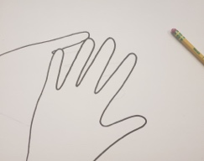

2. Next, place your hand on your paper and outline your second hand in pencil. Erase everything that is WITHIN the previous hand that is outlined in sharpie. This will make the hand appear BEHIND the first.

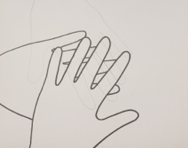

3. After you have your second hand drawn in pencil, you may trace your lines in sharpie. Your second hand should look partially covered by the first.

4. Next, you will continue the process by tracing your third hand on your paper. Erase ANY lines that go inside the previous two hands. Trace lines in sharpie.

5. Repeat these steps until you have all 5 hands drawn in.

6. Once all 5 hands are drawn, you may begin adding designs in the inside of each hand. In total, we want to create 10-12 VALUES. That means that each hand needs to have AT LEAST 2 different
designs (each design needs to be a different value.)

7. Once all hands have designs, you may trace over these in the SMALL sharpie. Ask Mrs. Harper if you have any questions!

